VPC Challenge
- Design and deploy a scalable network architecture using AWS Transit Gateway to simplify network connectivity between multiple VPCs.
Steps:
For this example, I have taken the 4 Vpc’s. we Create 4 vpc’s.

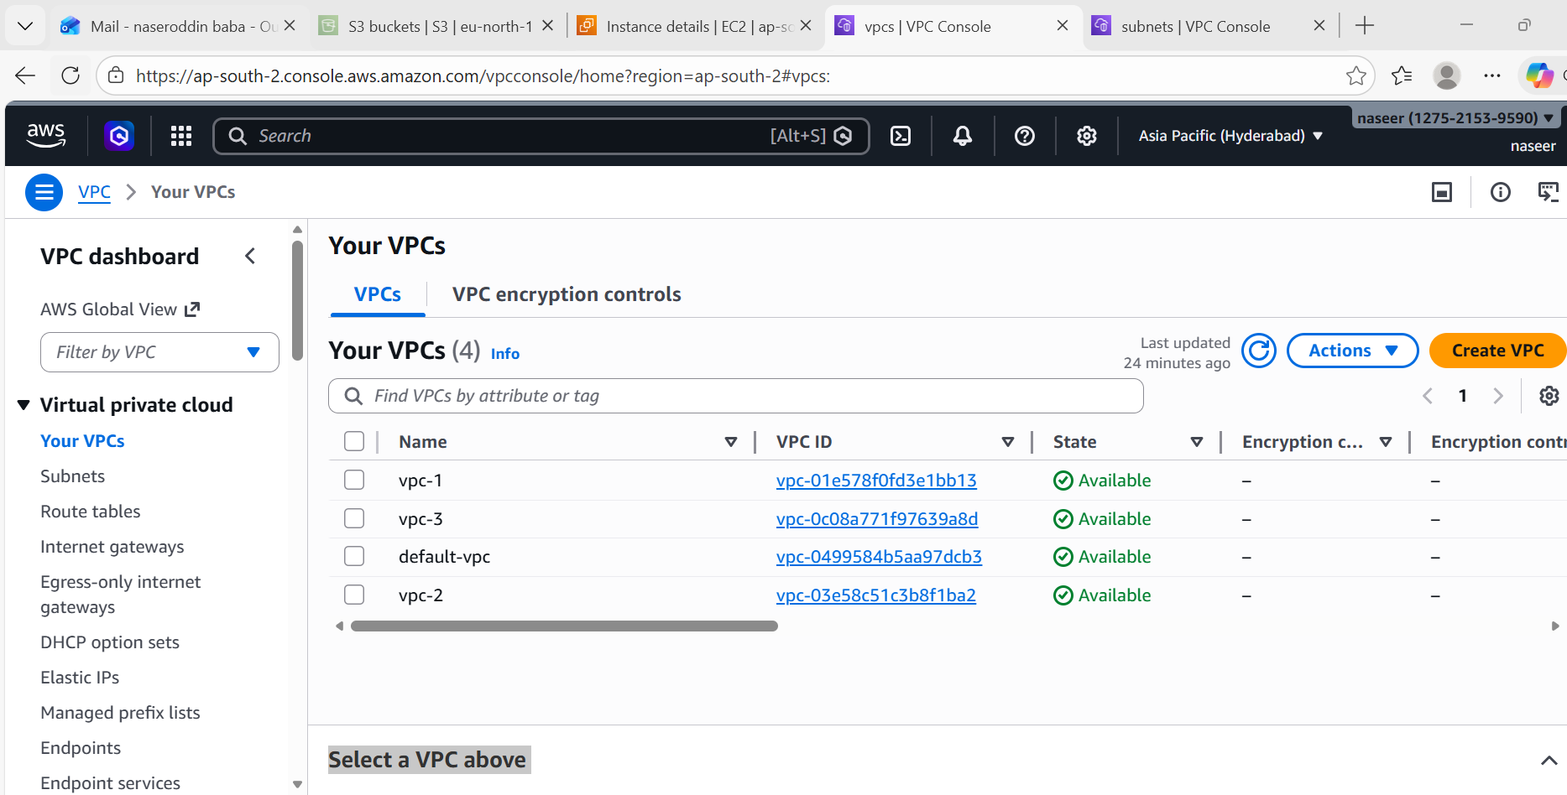

Step2: we create 3 subnets and take one default subnet
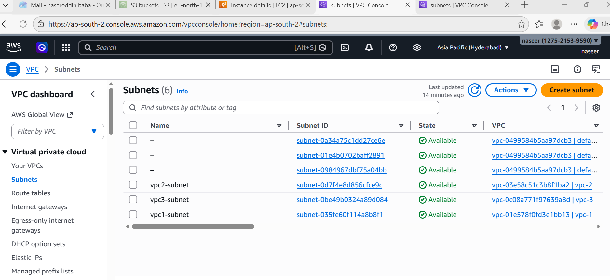
Step3: create 4 route tables
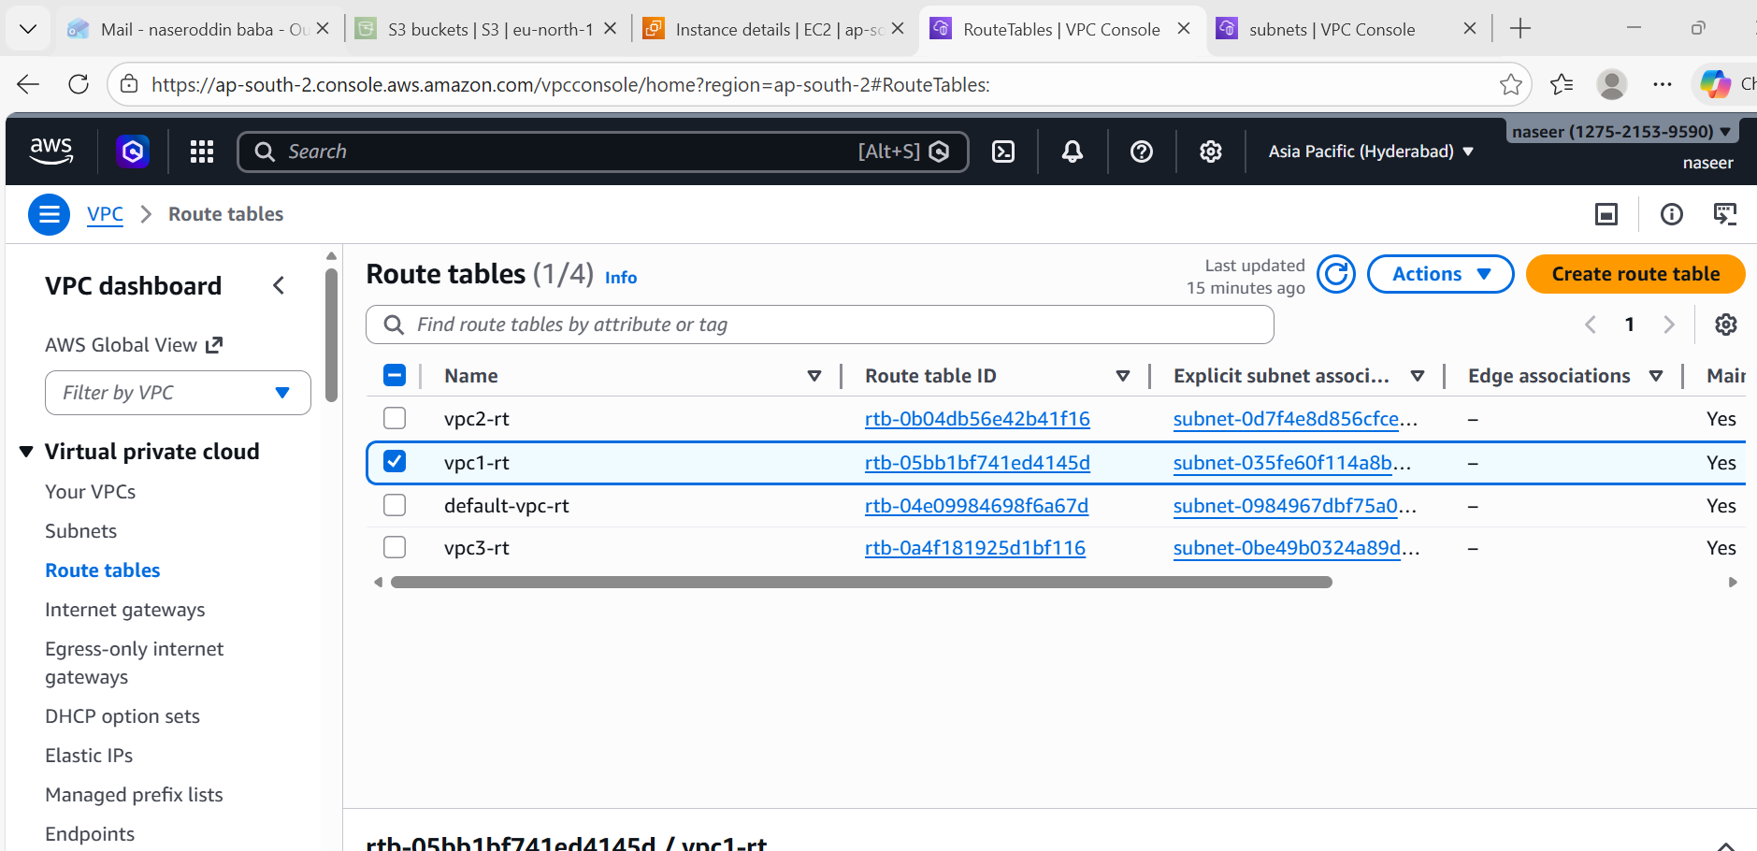

Step 4: create 4 internet gateways
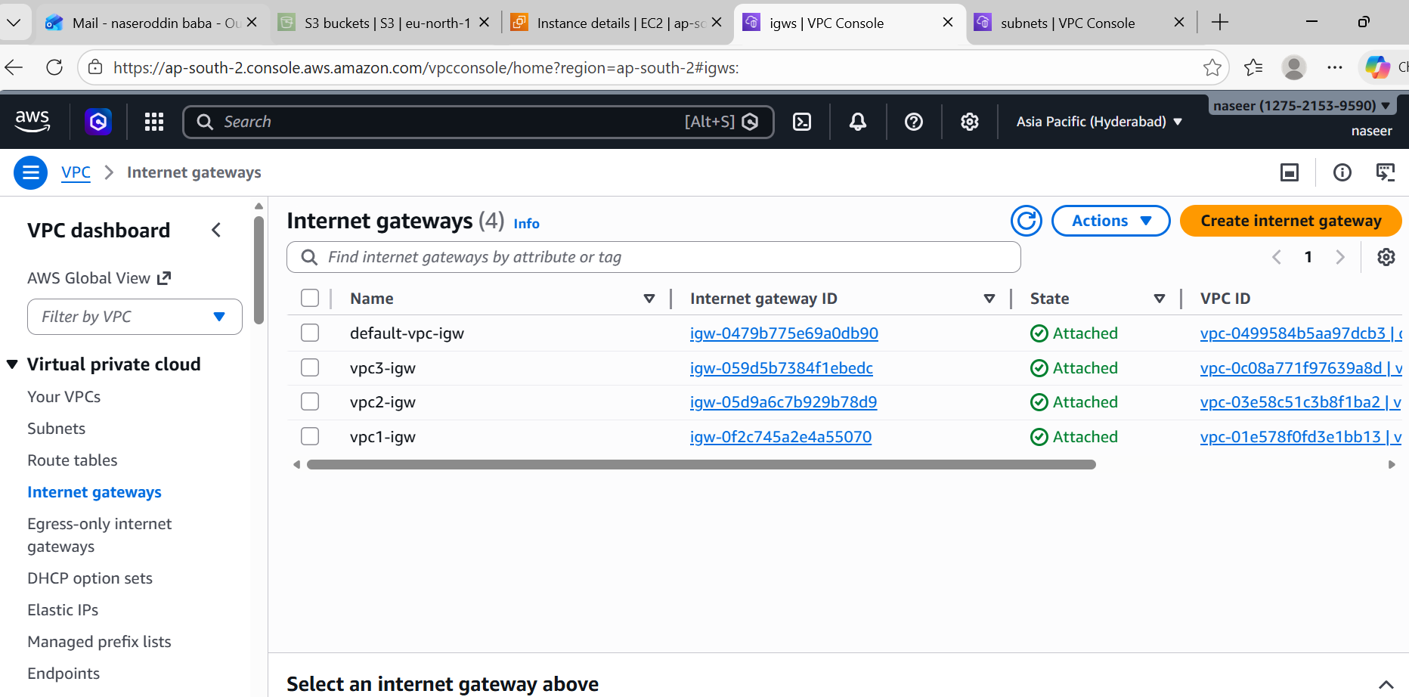

Step 5:
How to configure the Transit Gateway.
- First go to search bar and search for Transit gateway.
- Then click on create Transit gateway with default configuration(do not do any changes).
- Now go to transit gateway attachments and create each 4 attachments for 4 vpc’s
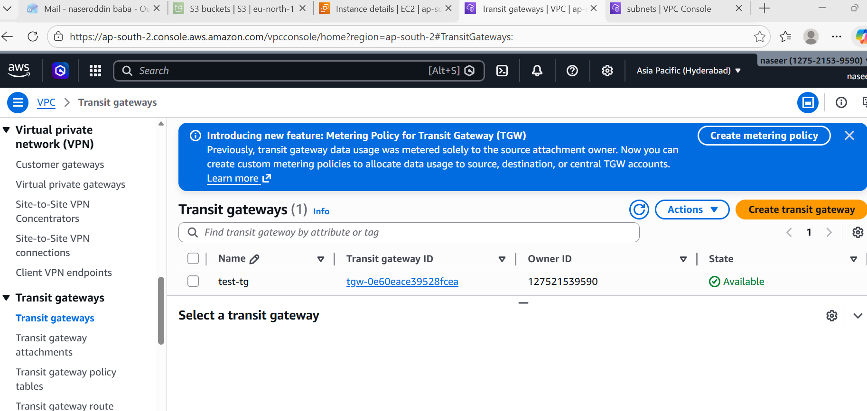

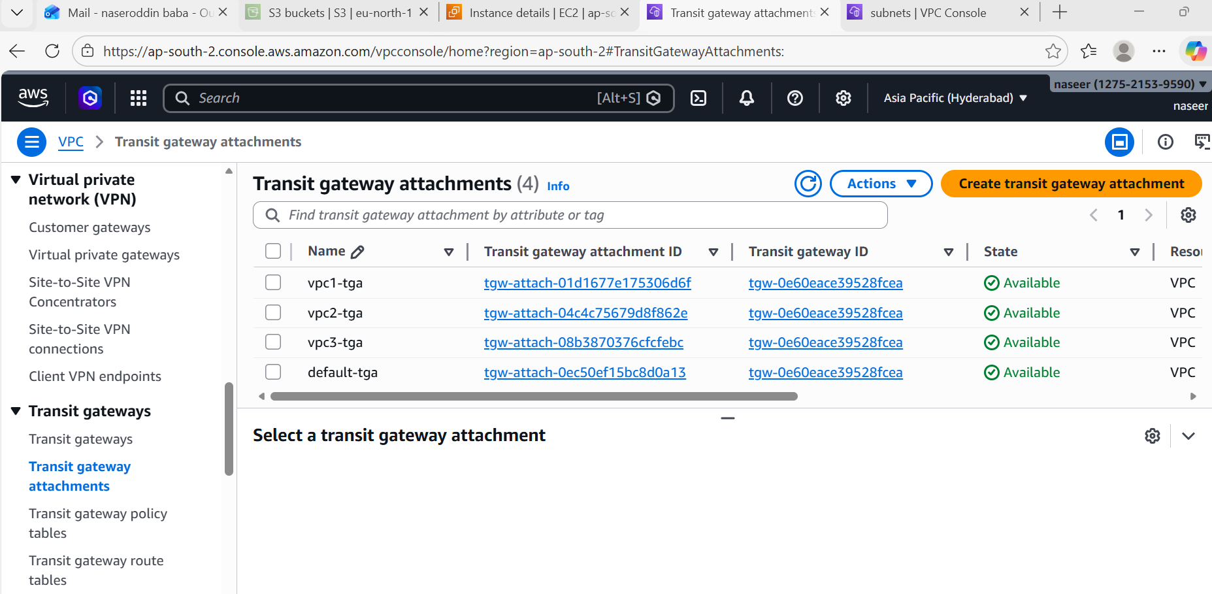

Step 6: After attaching goto transit gateway route table to check the status whether the vpc were are attached or not.
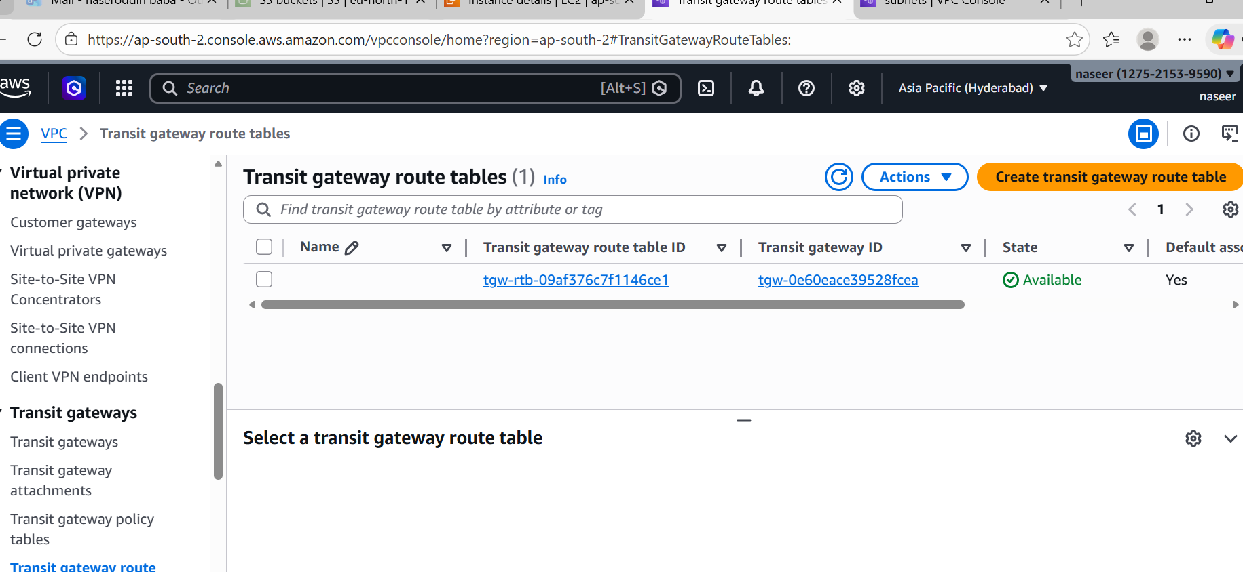
Step 7: Create 4 instances.
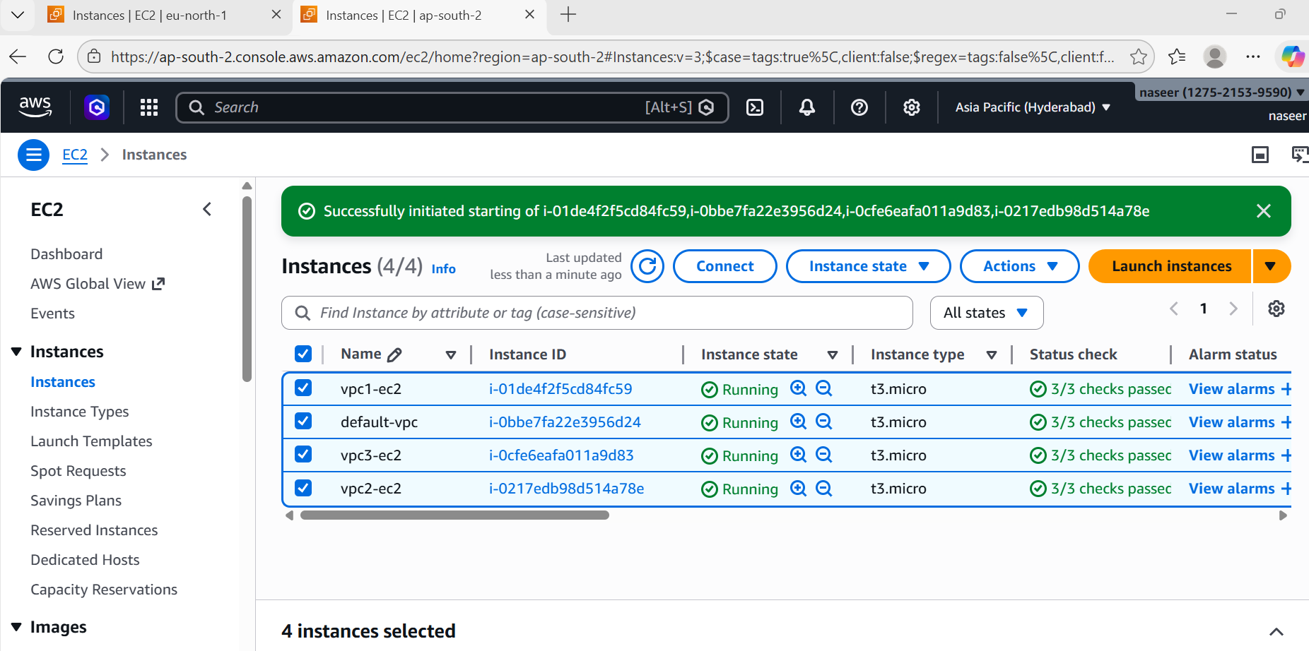

How to launch the Transit Gateway:
- Launch 4 instances with 4 vpc’s.
- Connect one instance with ssh (Make sure that all traffic’s should be opened for all 4 instances).
- Then try to connect to second instance with private IP (PING <PVT IP>).
- This time you can able to connect to instance because you have used Transit gateway.
- Then try to connect to instance 3 and instance 4 as well. It will connect to that instance.
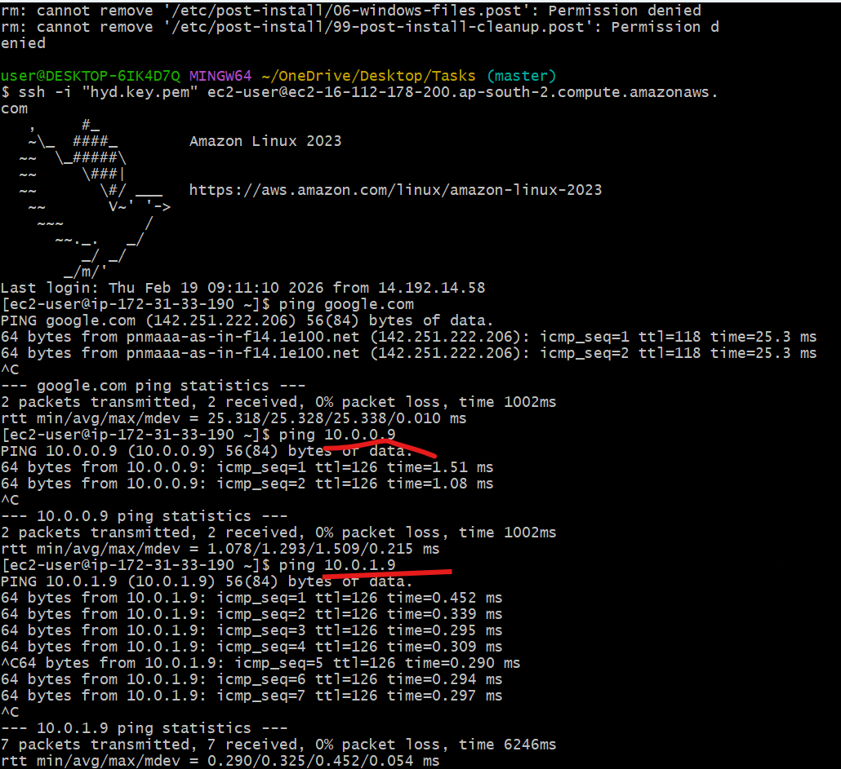

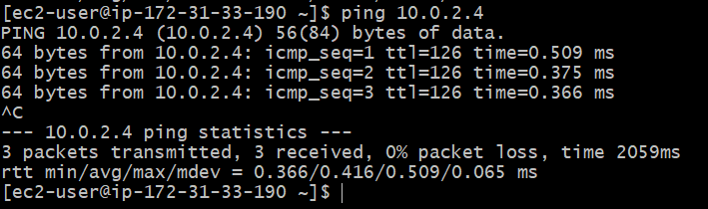

- Configure VPC endpoints to securely access AWS services without internet gateways or NAT gateways, ensuring data privacy and minimizing exposure to external threats.
Create one VPC with one public subnet and one private subnet.
Provide internet access to only public subnet.

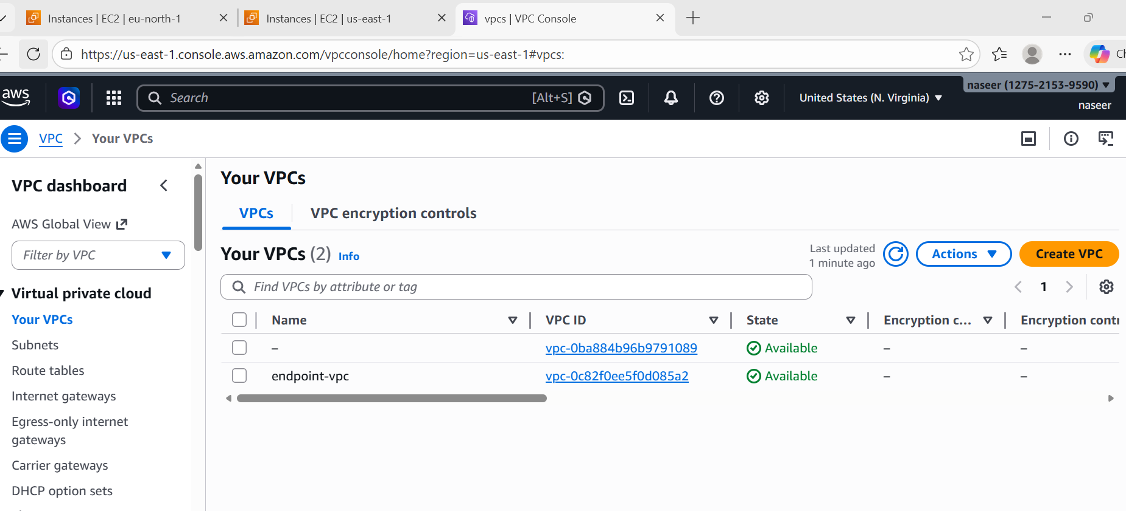
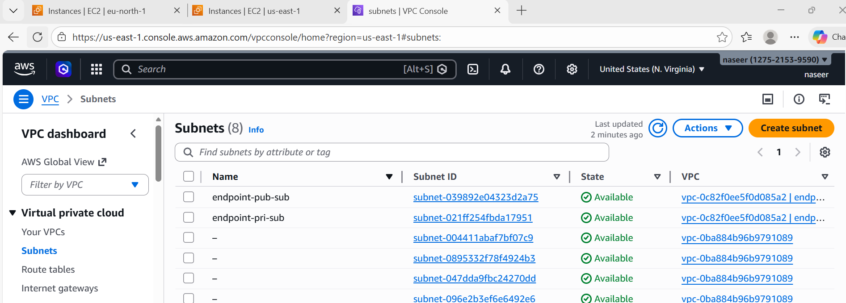

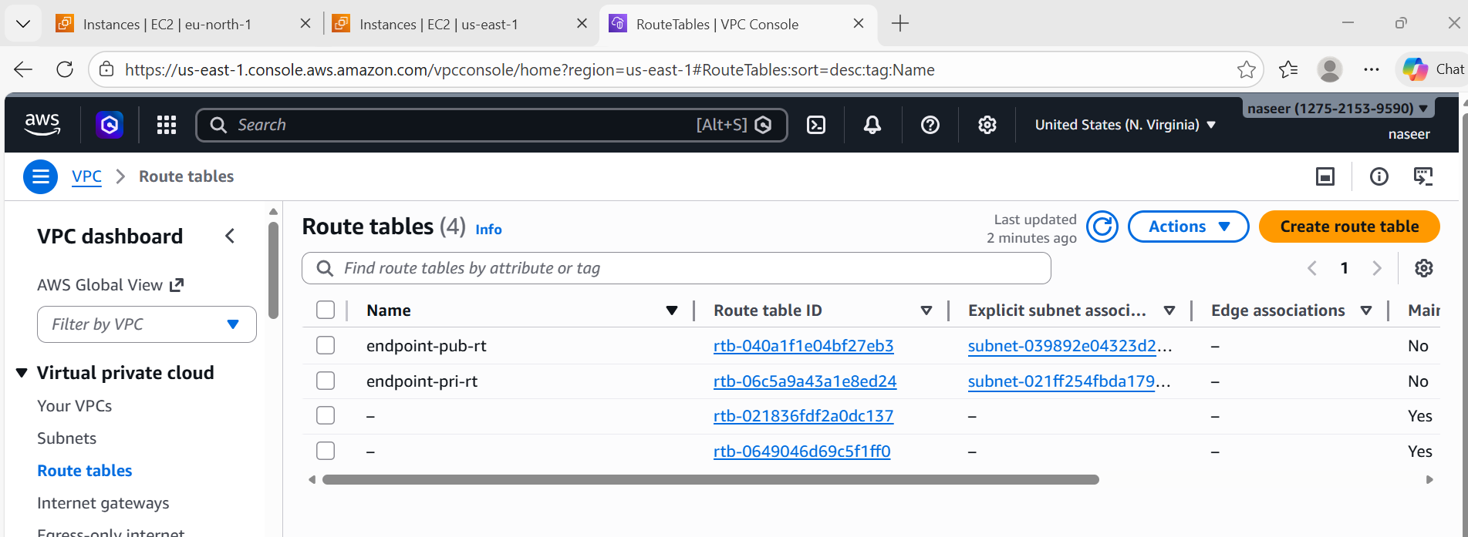

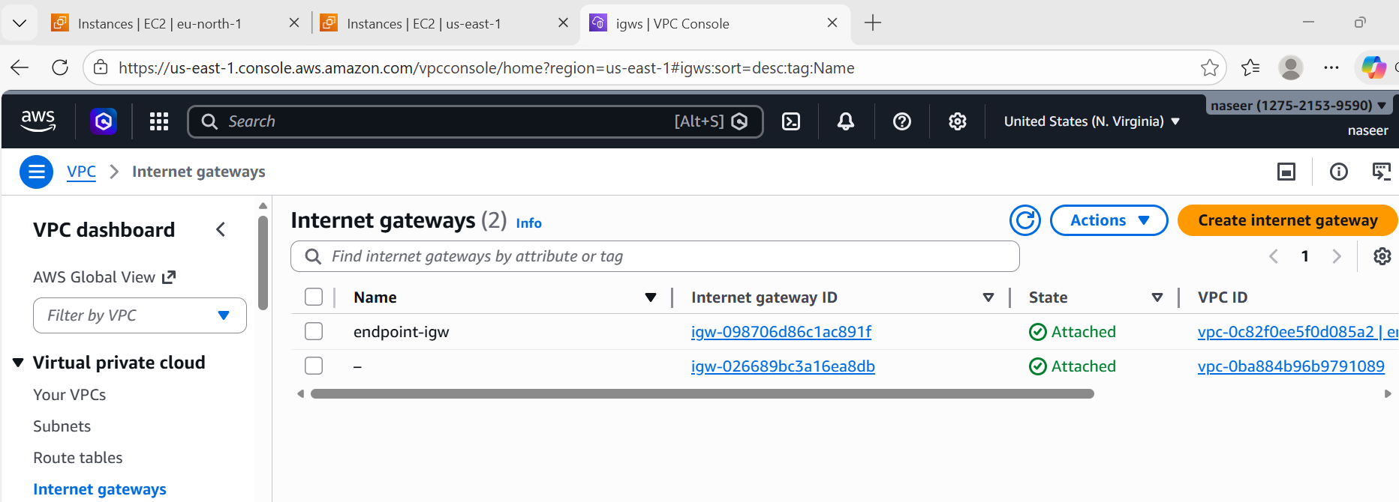
Launch one instance in public and one instance in private using the same VPC.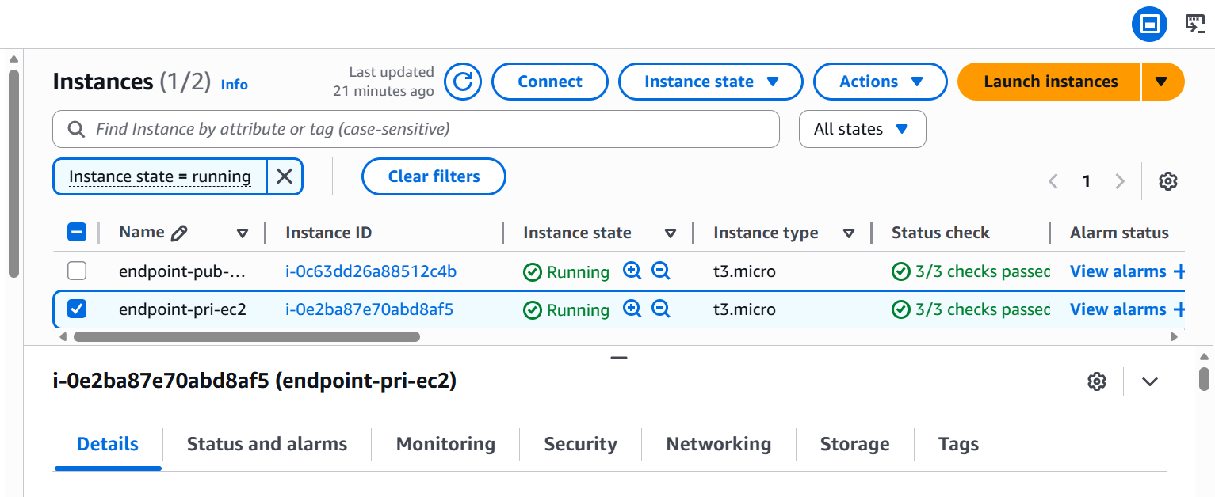
Now to go to VPC Endpoint service and create a Vpc endpoint.
How to Configure VPC end point:
- First go to Vpc & under vpc you will find end points.
- Give a name for the endpoint & select the service category as aws.
- Then select the service as s3 and add any one of the service gateway.
- And the select the VPC & choose the route table as private.
- Then click on create endpoint and endpoint will be created and added to private route table.

